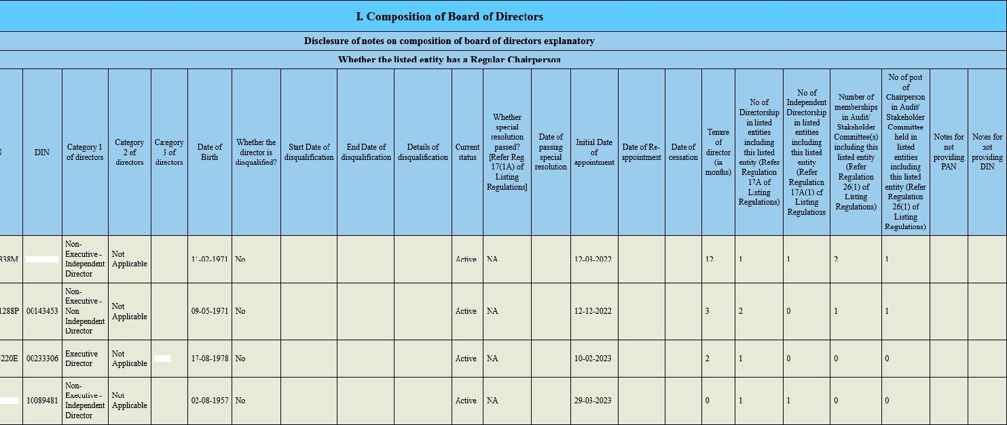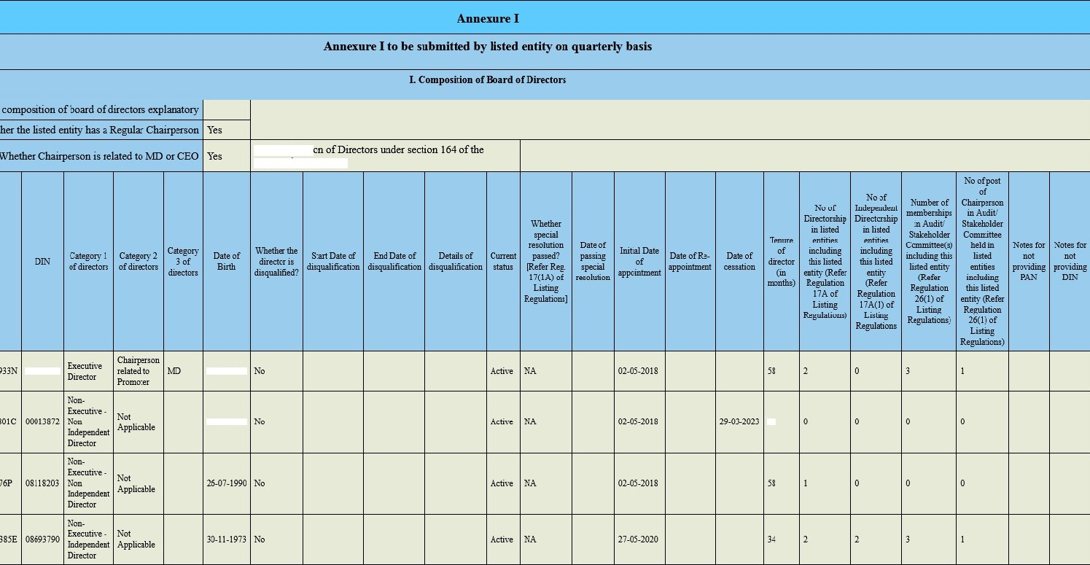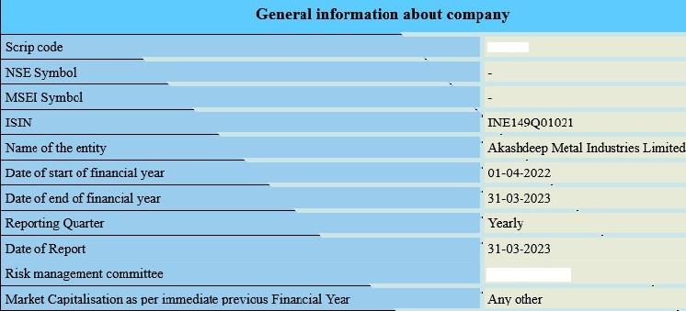
CEO
60'/H
Disqualificati Companies Act, 2013
00006056
07-11-1963
3T0II933
5D
538778
Not Applicabla

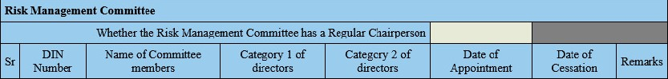
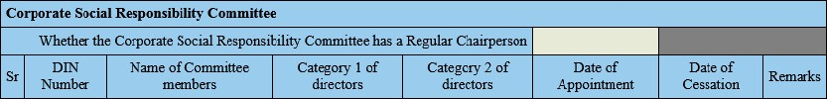
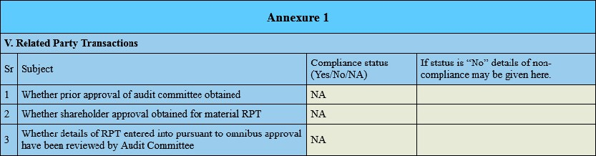
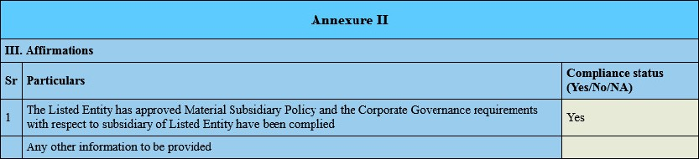
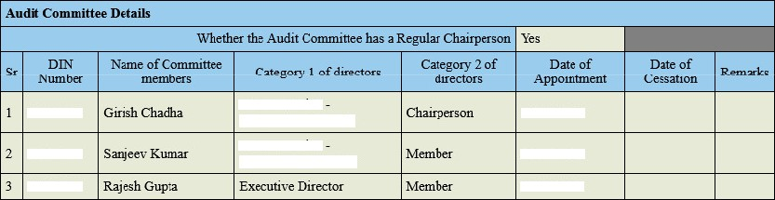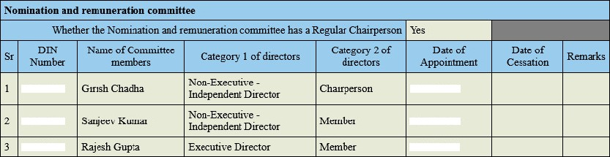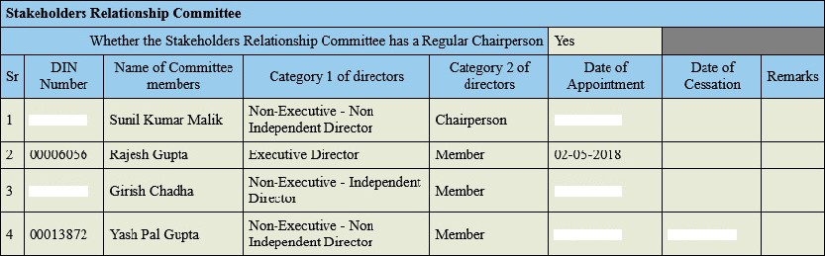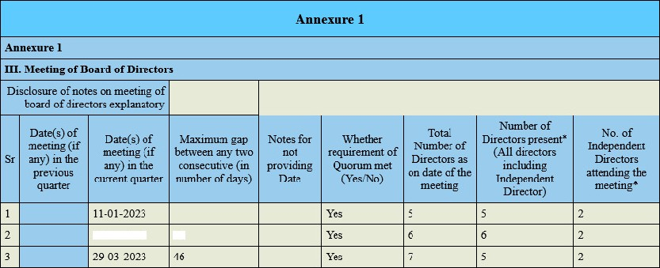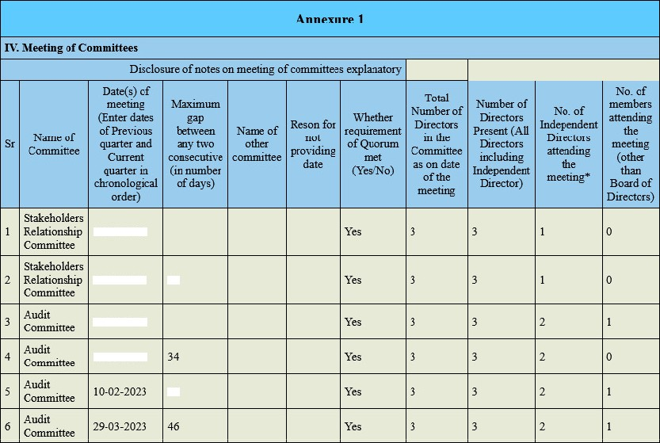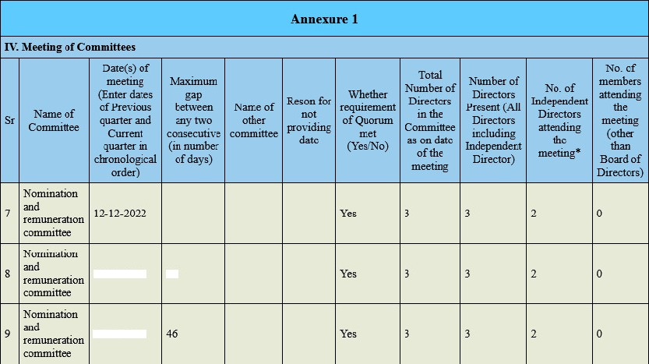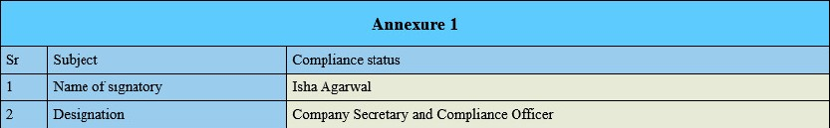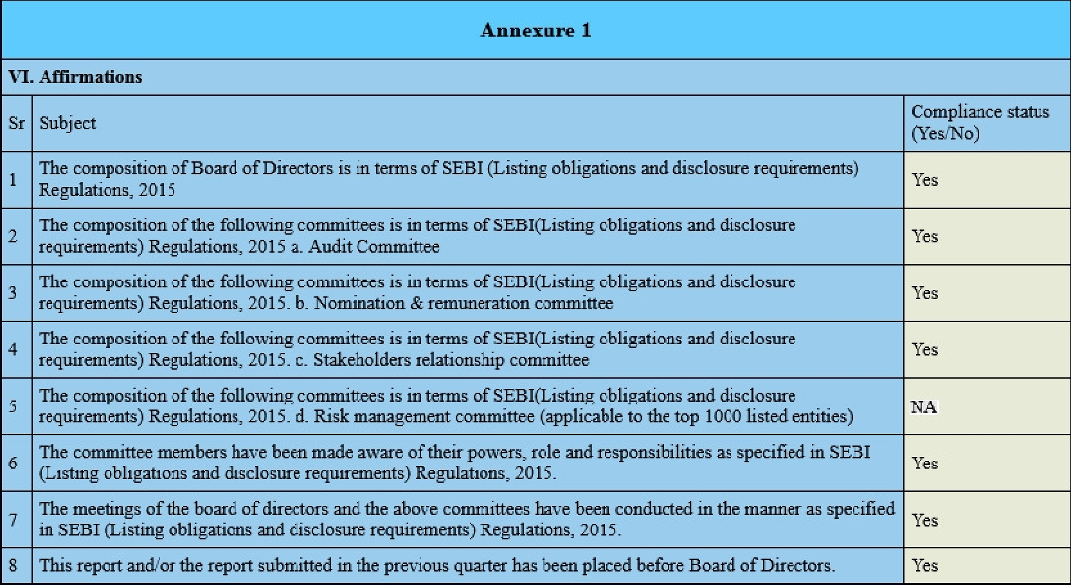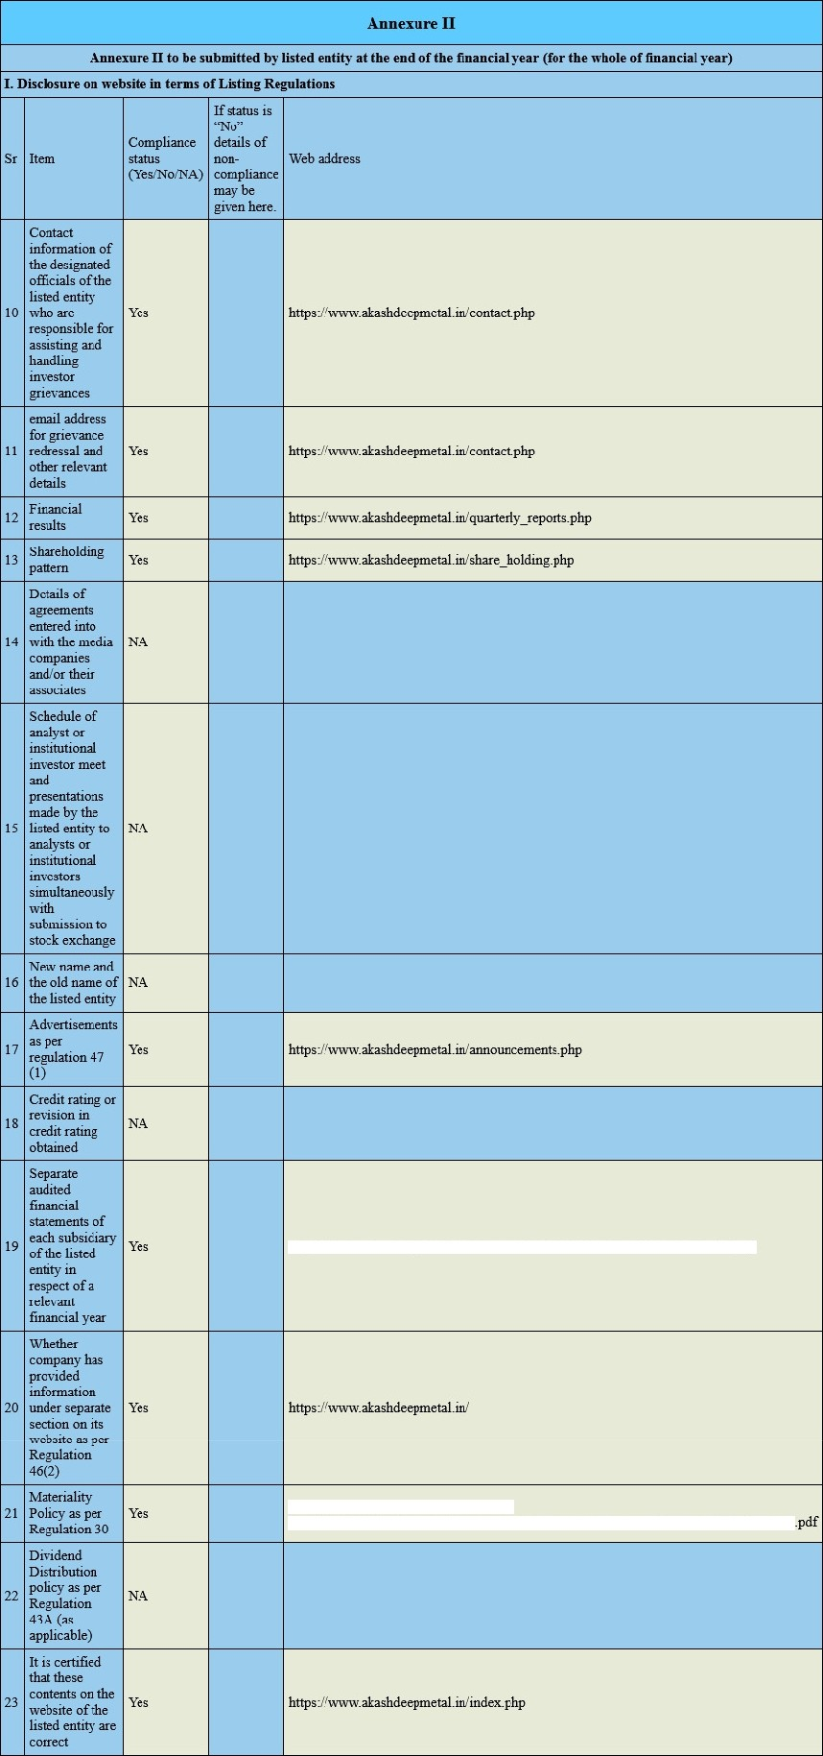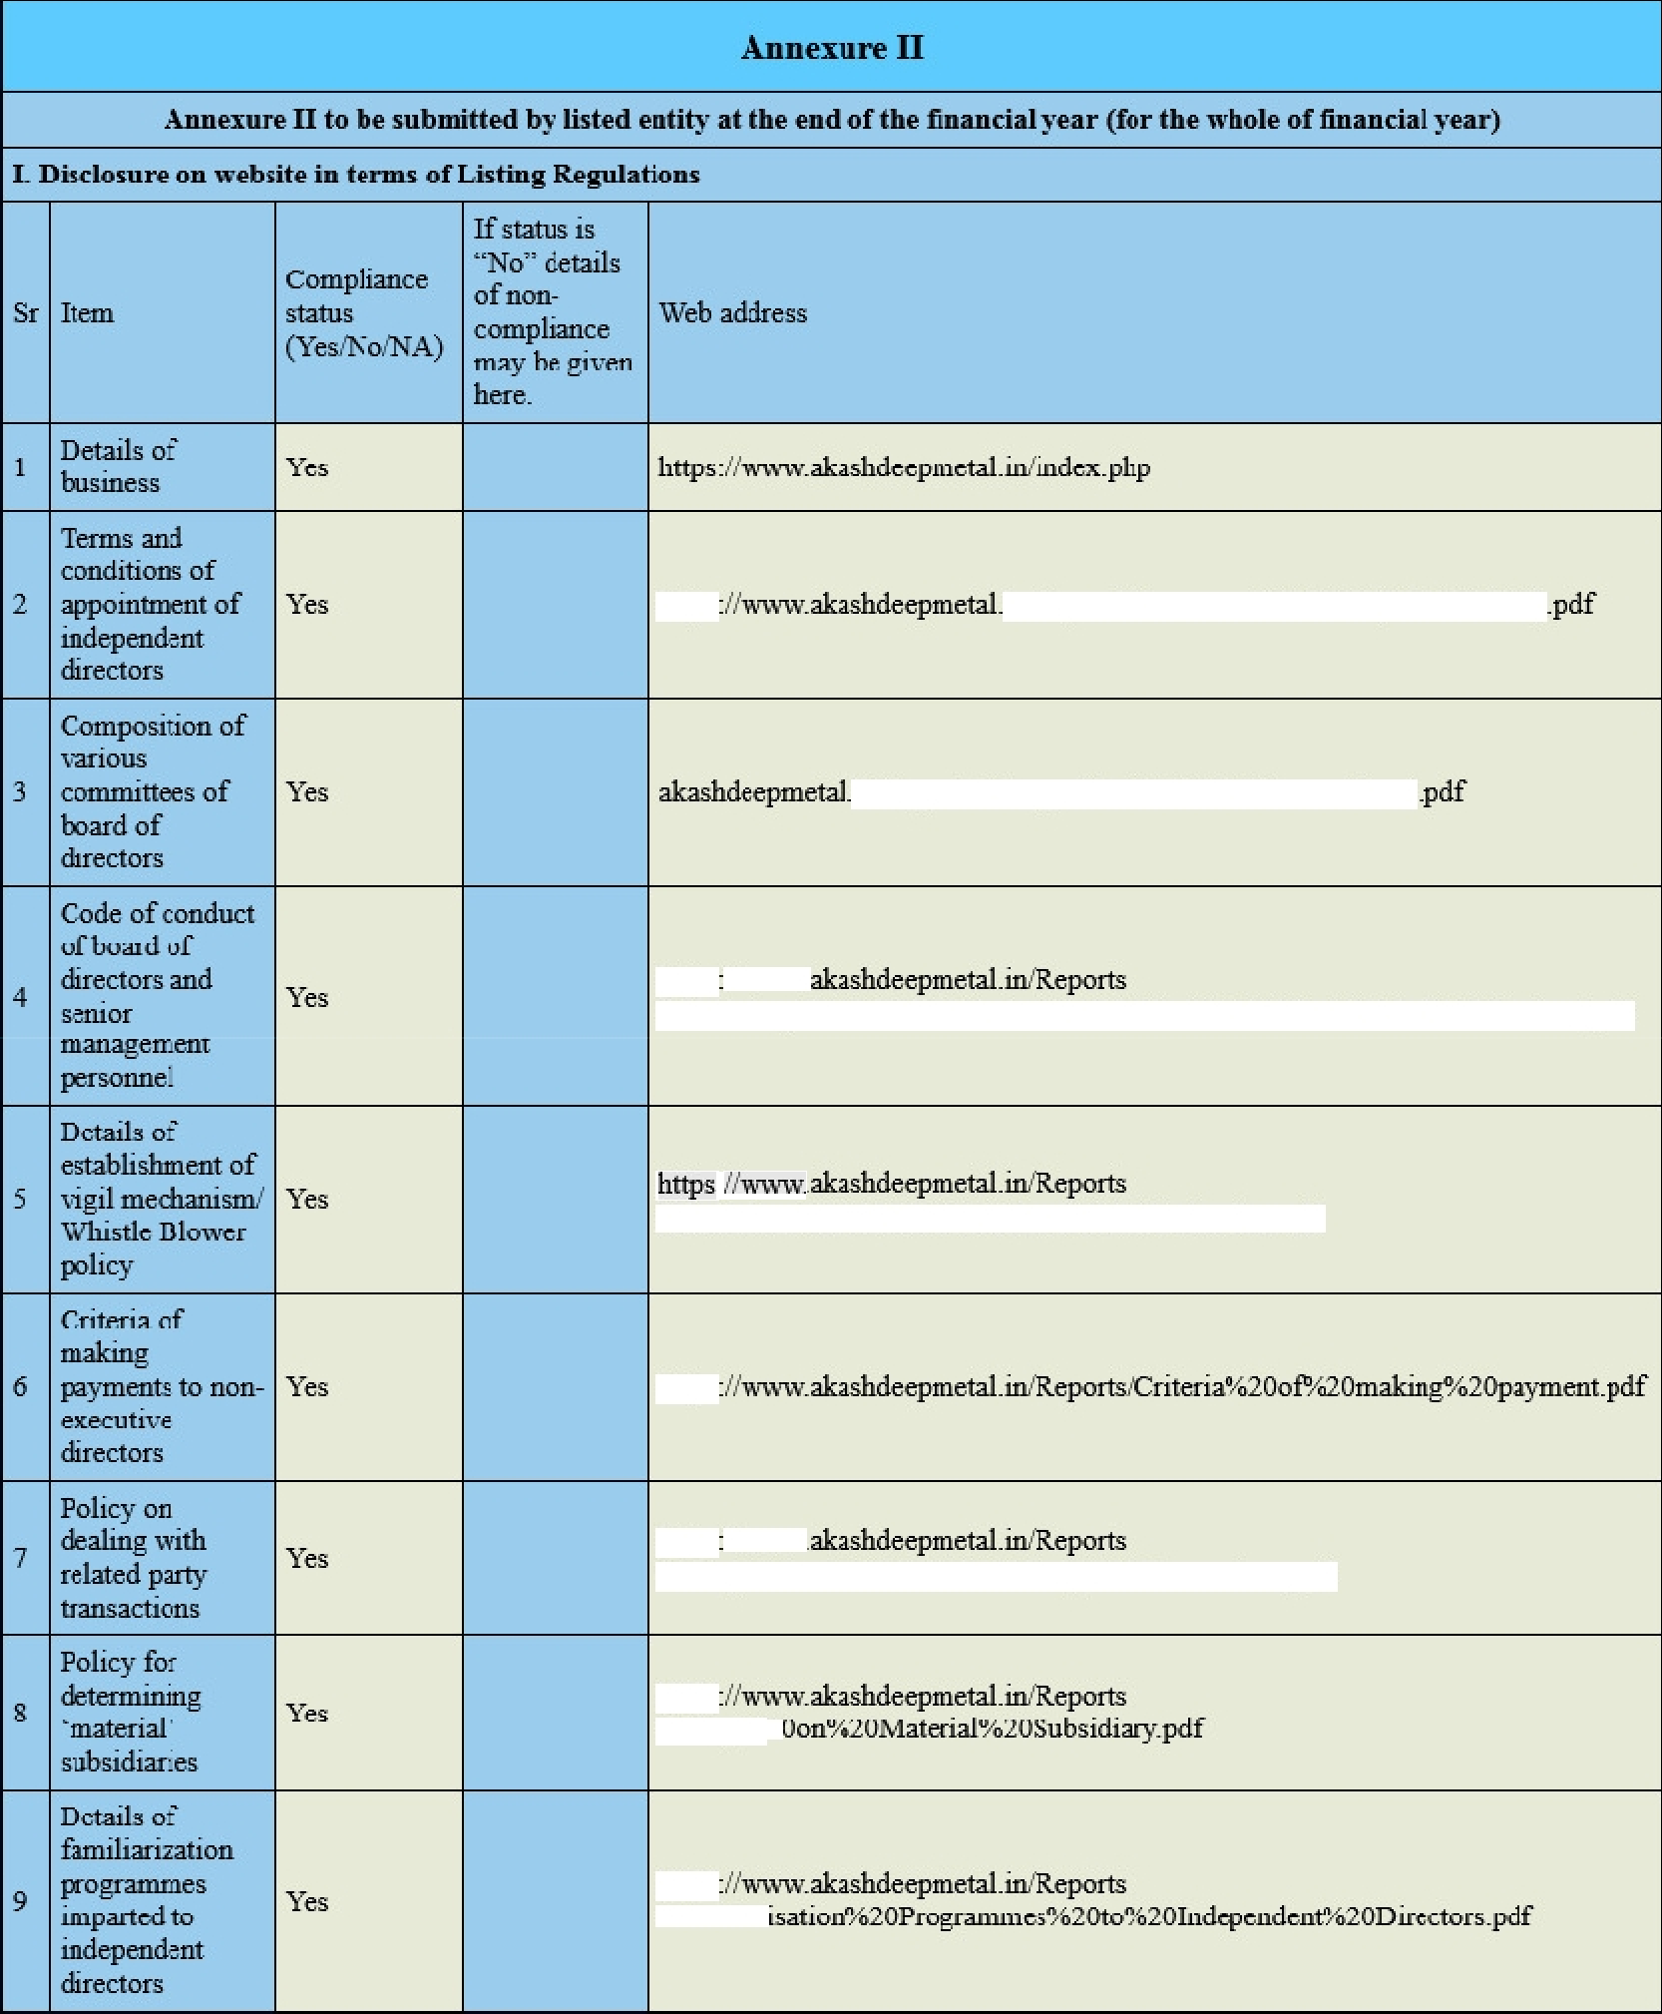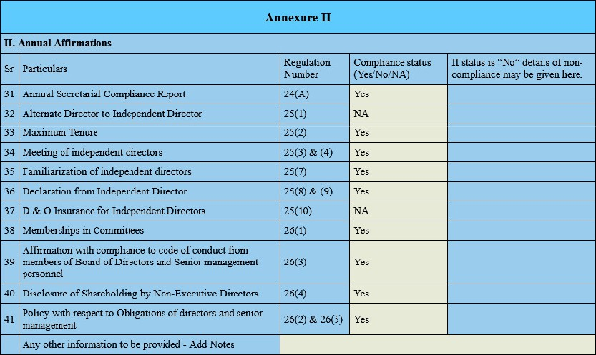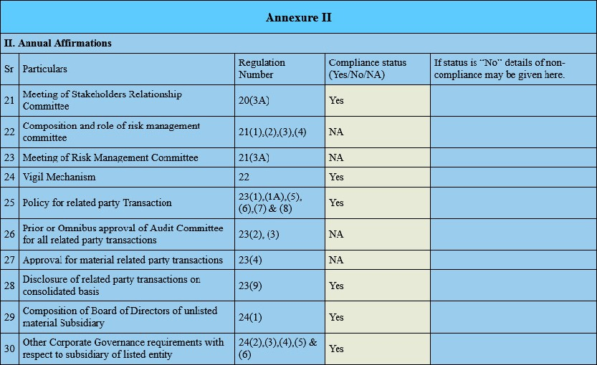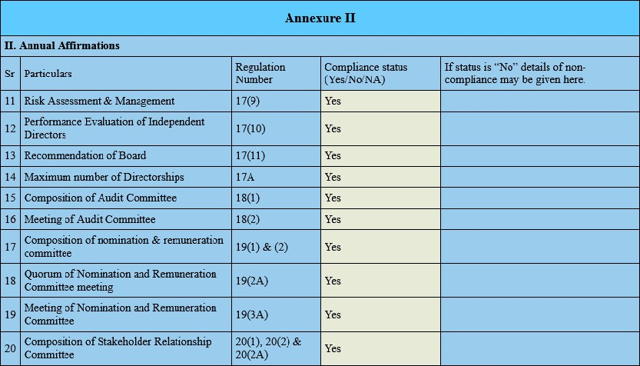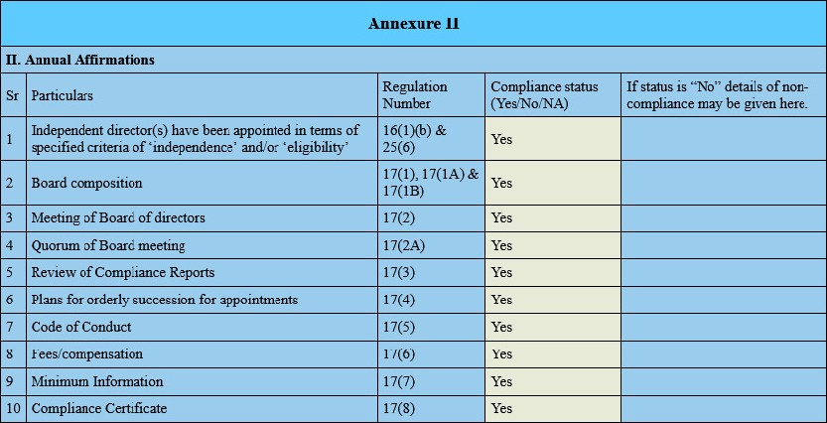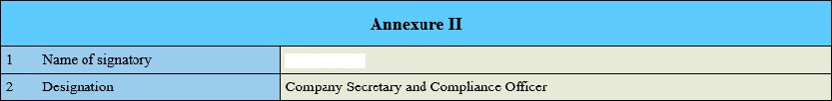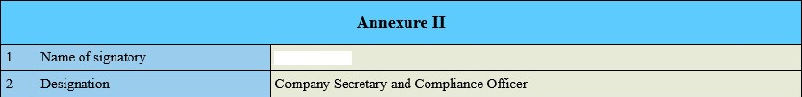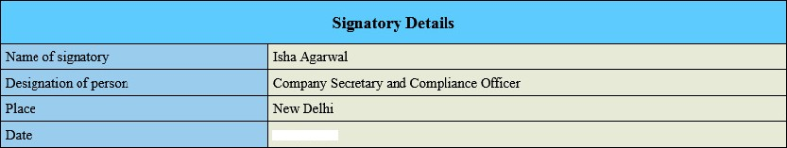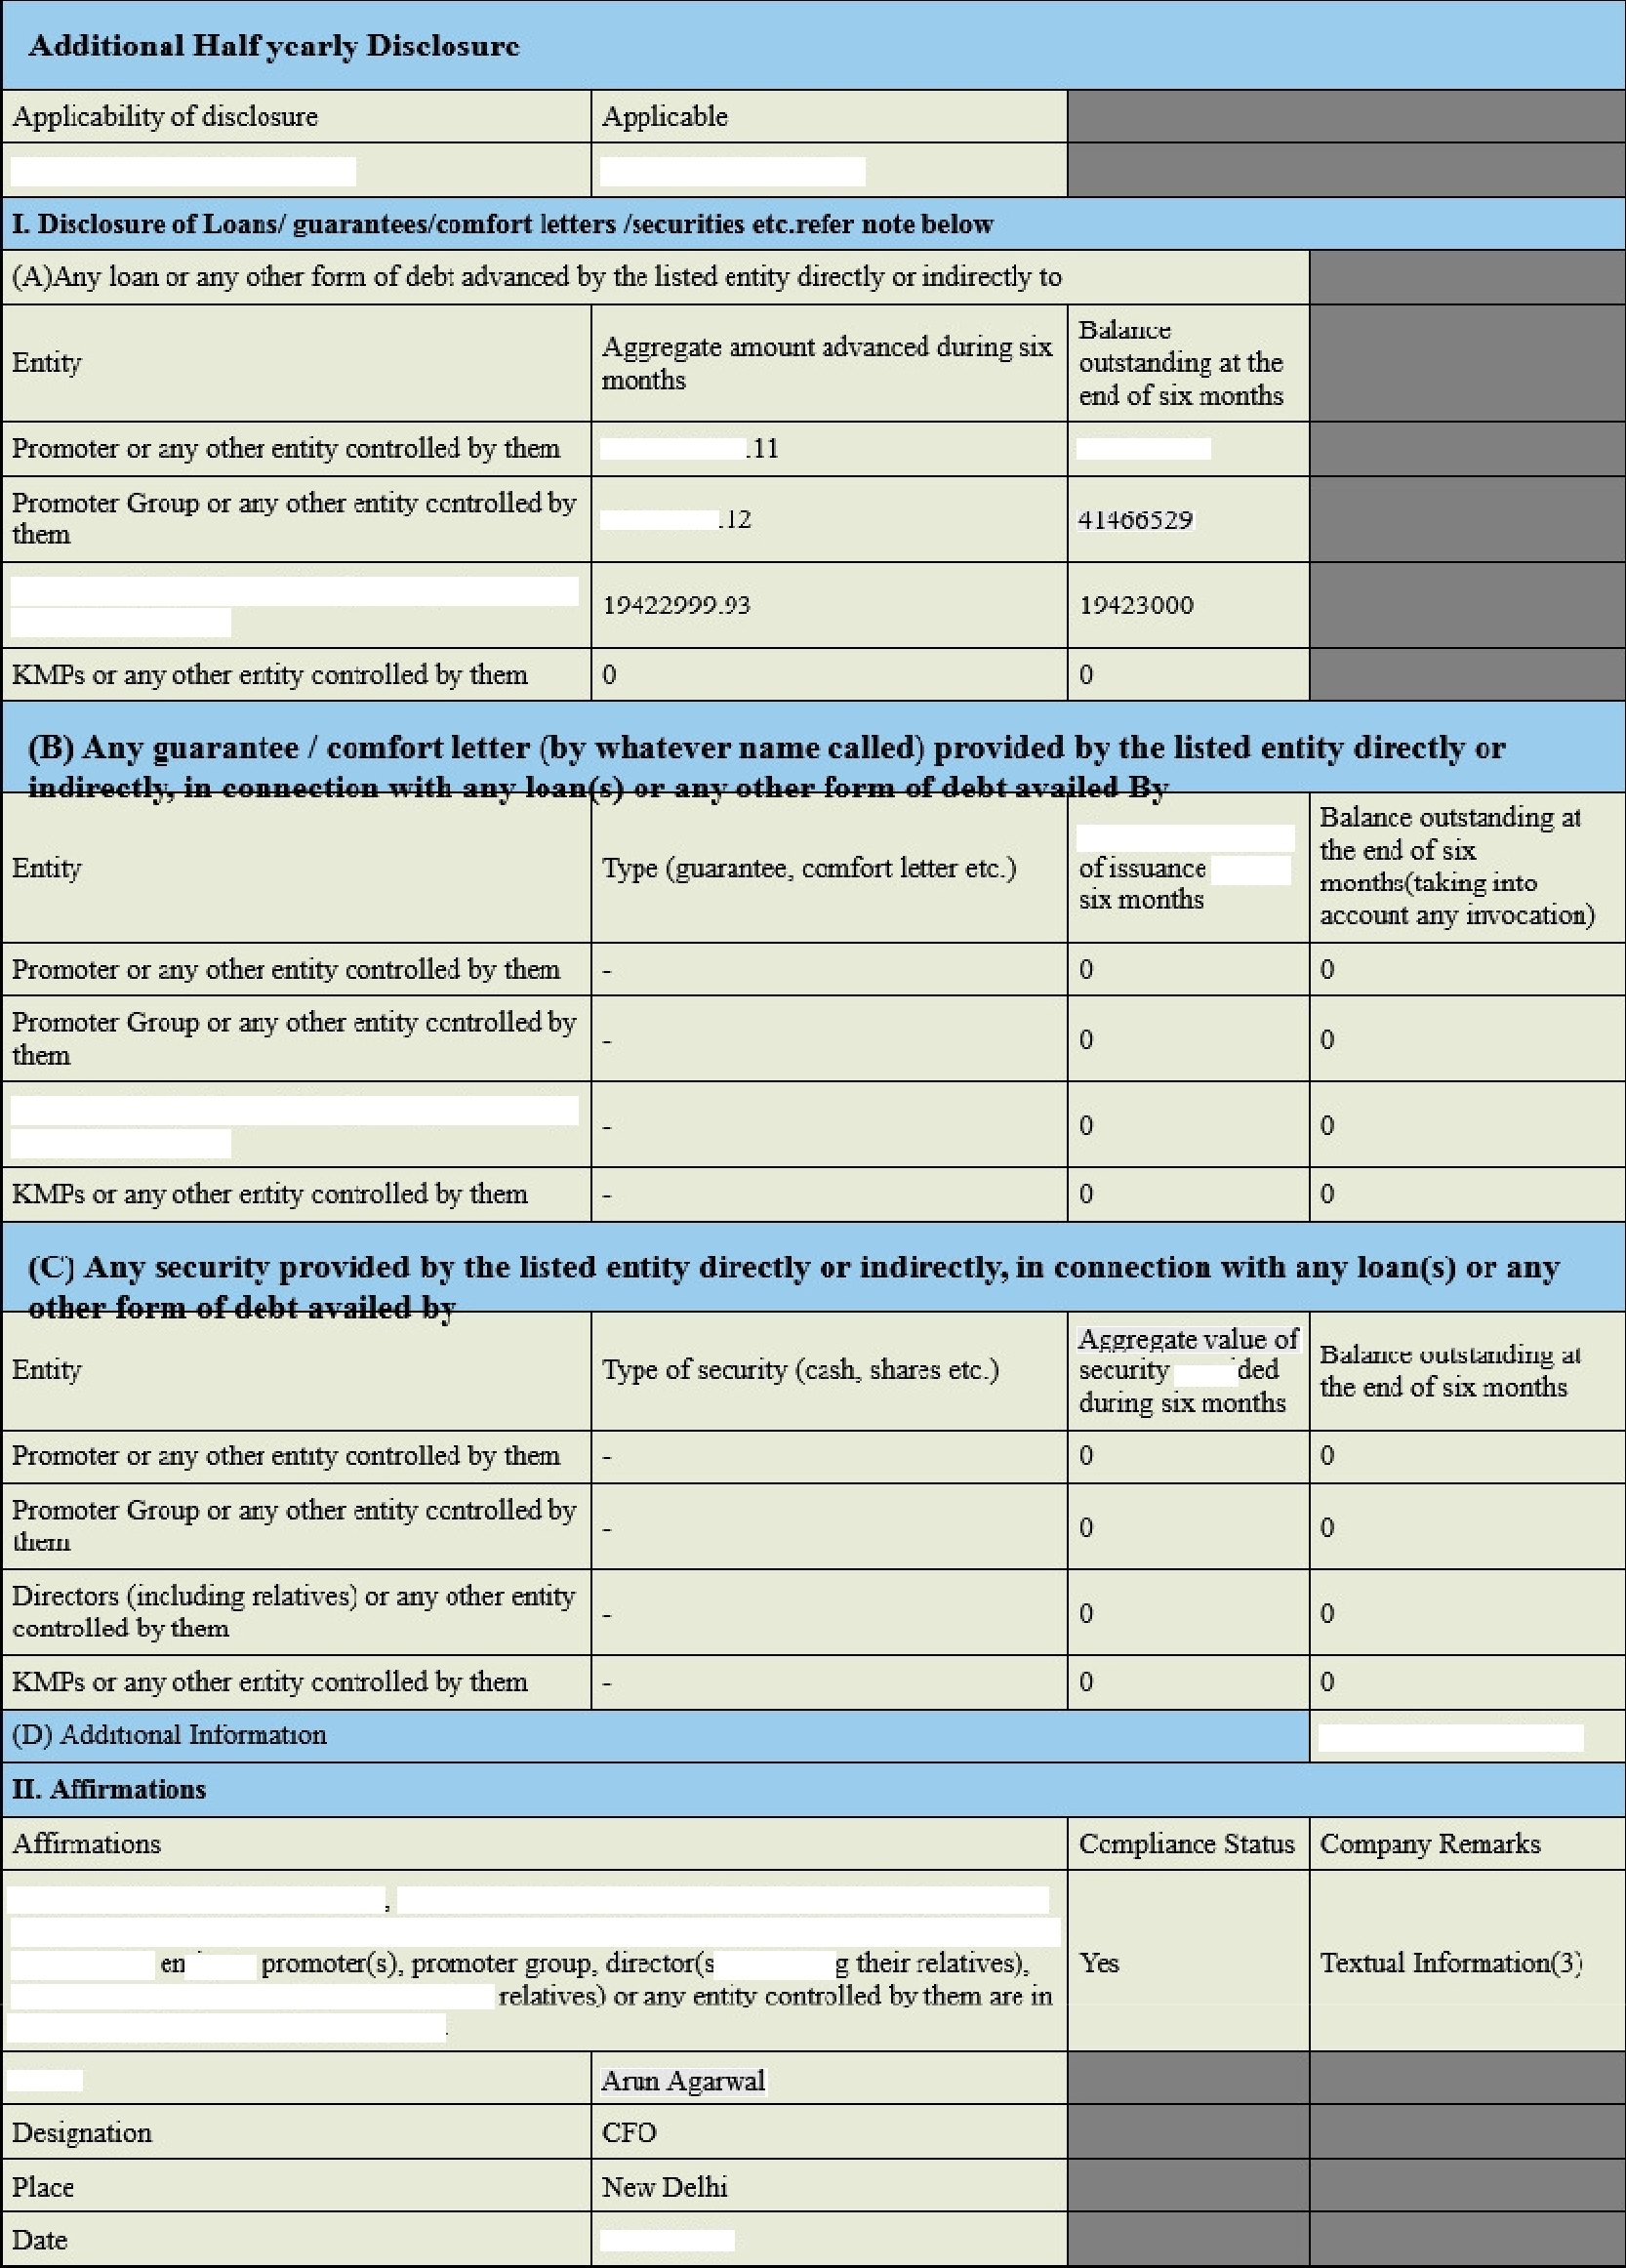
0180864?
NonExecuüie
bdqxdiDú=v
Nou-Execuuve
Infi•pendezd Director
12-03-2022
08693790

O0O60S6
27-05-2020

02-05-2018
0180864?
12-03-2022
Ofi ó93790

O0O60S6
27-03-20?0

02-05-2018
6143413
12-12-20U
01808647
12-03-2022
02-05-2018 29-03-2023
10-02-2023 29
11-10-2022
05-01-2023 85
07-11-2022

12-12-202?
S9
10-02-2021 59
29-03-2023
https iir'Reports 'Aiuiexure%203%20(T&C0ó20-O)
in'Reports 'ComposiuoNó20oPí›20committeesl
https 7'vnwv.
.'Akashdeep%20MetaI%20Industries%e20Limited°í20Co4e%‹›20of'‹›20Conduct.péf
.'Akashdeep°í20IVhistle%«20Blowei'íó2CMechainsm.pdf
https 7'uwwv.
.'Policy%20on%+20Related%20Party°%2('Transactions.pdf
httpsú'mv'.akasbdeepmetal.in''.Anmol°ó20Financial°í20Serv ices%o20Limiteóphp
https?'.'svwv'.a ashdeepmetal.in'Reports
.''.Akas1ideep%20Policy’«20for’*«20Determination%20o%20Mateiiality’fi20of•‹20Events
Isha .Agmval
Isha .Agmval
Reason for Non App1.cability
Teztuat Itz ormaúon(1)
2635343637
2SB99463?
4.7751300
Directors (mcluding relatives) or any other enfity cootmlled by them
Aggregate amount
Directors (mcluding relatives) or any other enfity cootmlled by them
Textual Intòimation(2;i
All loans (or other four of debt) evararitees, ‹omfort letters (by whatever nama called) or securities in connection with any loan'(s) (or other form of debt) given directly or indirectly by N hsted .tity to .) (incliufin
key managerial personnel ineliAine their the economic interest of the company-.
Name
21-04-2023
21-04-2023

